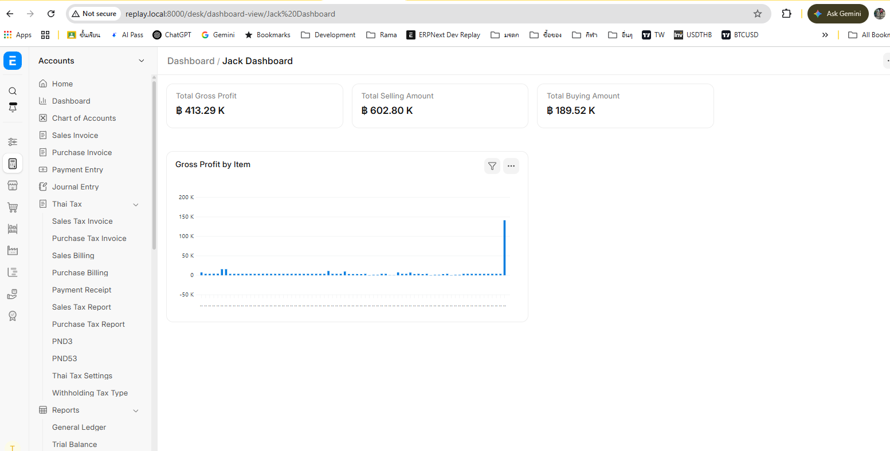
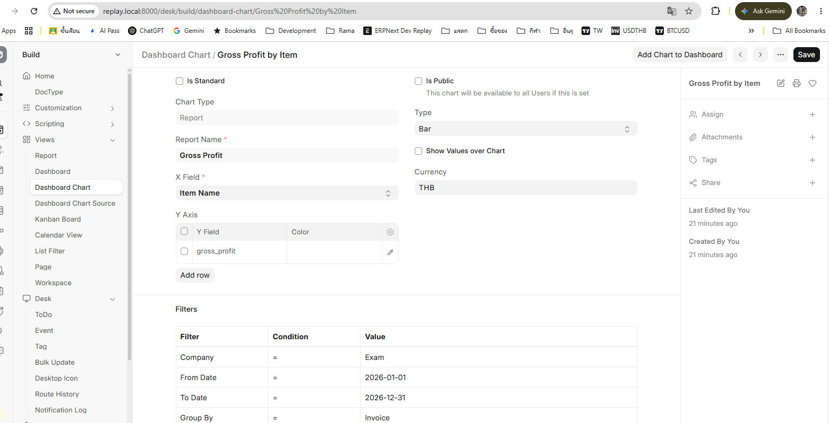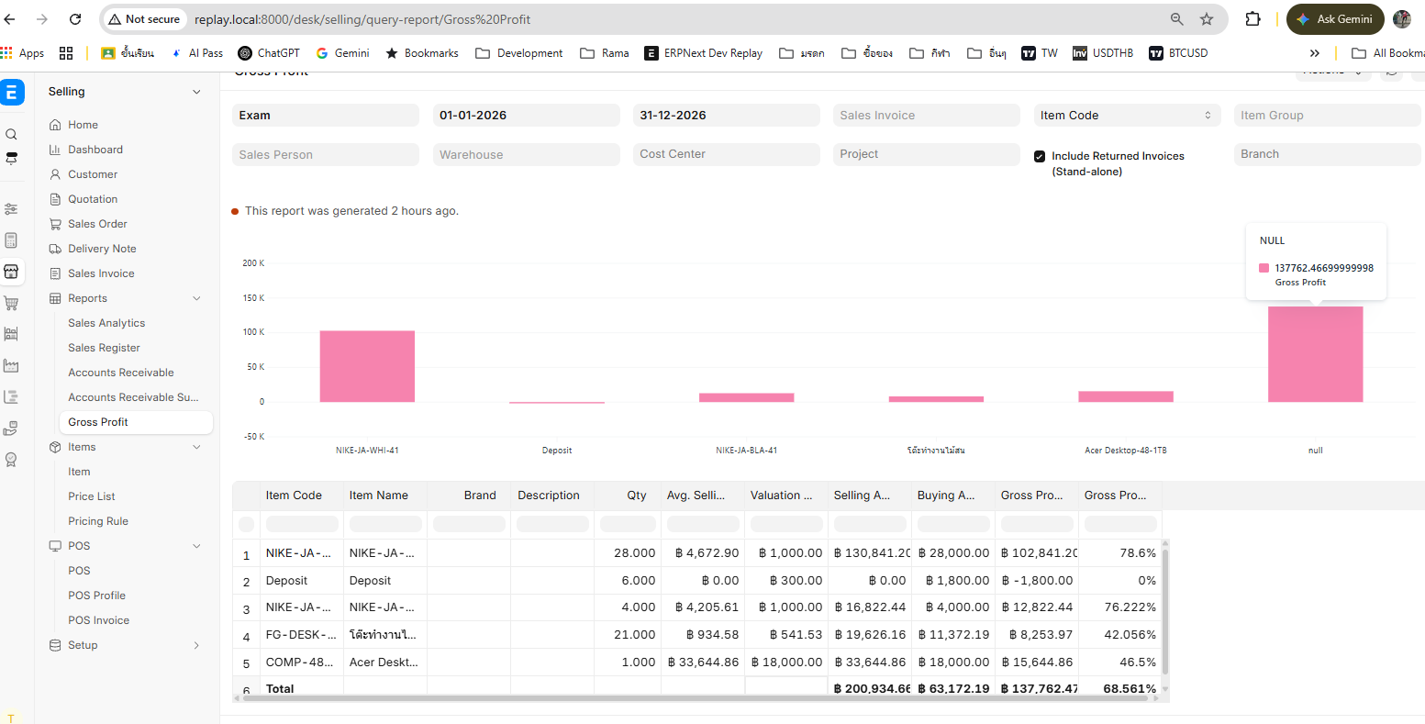
Dashbaord Setting
{"name":"Gross Profit by Item","owner":"Administrator","creation":"2026-11-06 14:21:51.562267","modified":"2026-11-06 14:21:51.562267","modified_by":"Administrator","docstatus":0,"idx":0,"is_standard":0,"module":null,"chart_name":"Gross Profit by Item","chart_type":"Report","report_name":"Gross Profit","use_report_chart":0,"x_field":"item_name","source":null,"document_type":"","parent_document_type":"","based_on":"","value_based_on":"","group_by_type":"Count","group_by_based_on":null,"aggregate_function_based_on":null,"number_of_groups":0,"is_public":0,"heatmap_year":null,"timespan":"Last Year","from_date":null,"to_date":null,"time_interval":"Yearly","timeseries":0,"type":"Bar","show_values_over_chart":0,"currency":"THB","filters_json":"{\"company\":\"Exam\",\"from_date\":\"2026-01-01\",\"to_date\":\"2026-12-31\",\"group_by\":\"Invoice\",\"include_returned_invoices\":1}","dynamic_filters_json":"{}","custom_options":null,"color":null,"empty_state_message":null,"last_synced_on":null,"doctype":"Dashboard Chart","y_axis":[{"name":"04rkq1o1s0","owner":"Administrator","creation":"2026-11-06 14:21:51.562267","modified":"2026-11-06 14:21:51.562267","modified_by":"Administrator","docstatus":0,"idx":1,"y_field":"gross_profit","color":null,"parent":"Gross Profit by Item","parentfield":"y_axis","parenttype":"Dashboard Chart","doctype":"Dashboard Chart Field","__unsaved":1}],"roles":[],"__last_sync_on":"2026-11-06T07:21:51.607Z"}

